Assignment 1-part C

Moucheng Mao 2172503

Linus Sison 2180763

**Pre-training script**

Model Thresholds used:

low Hue = 0

low_Sat = 0

low_lum = 3

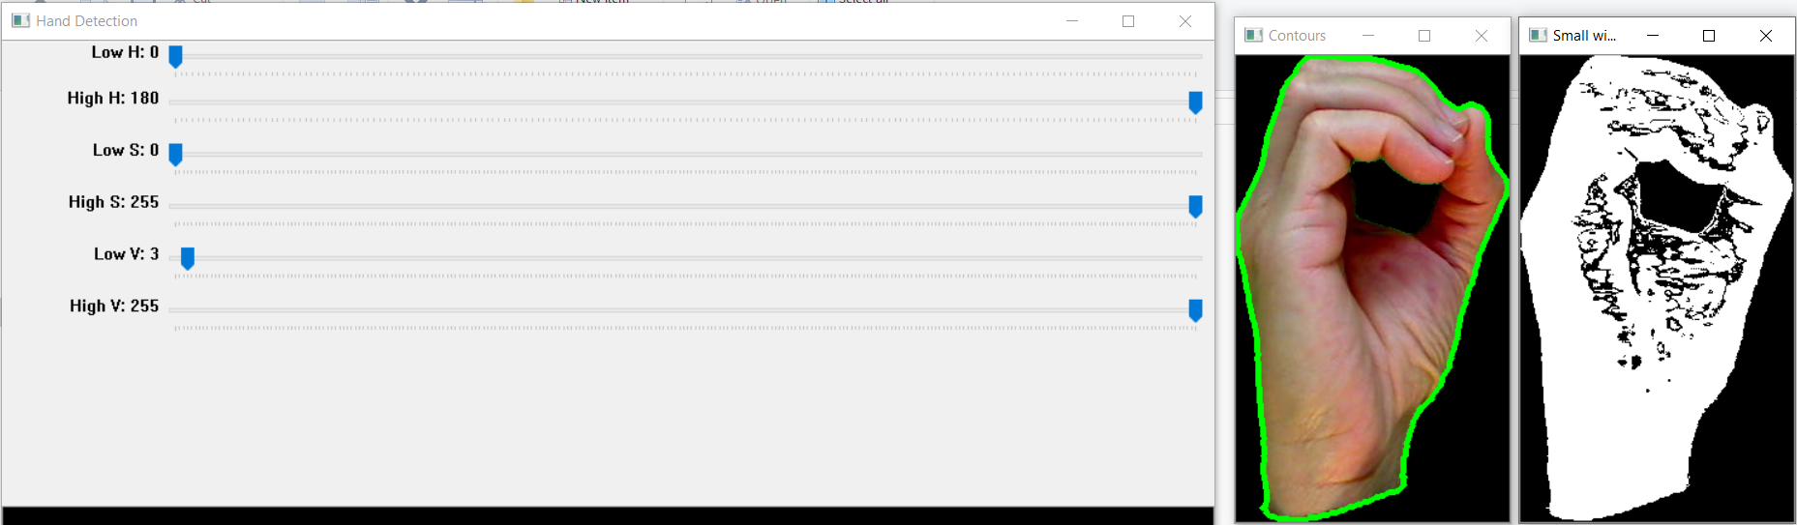

Computing the binary image by tweaking the thresholds: These values resulted the best in getting the right edge detection and contour detection.

**Training Script**

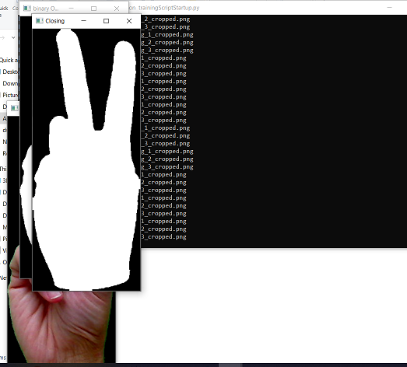

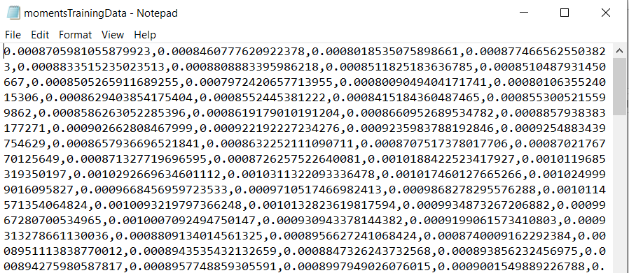

Training script ran and stored in a text file in a CSV format.

**Self-evaluation phase ( Testing Script )**

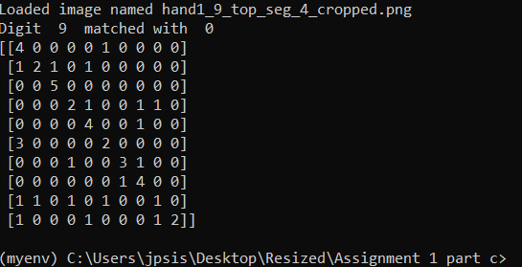

|  |  |  |  |  |  |  |  |  |  |  |  |  |  |  |  |  |  |  |  |  |  |  |  |  |  |  |  |  |  |  |  |  |  |  |  |  |  |  |  |  |  |  |  |  |  |  |  |  |  |  |  |  |  |  |  |  |  |  |  |  |  |  |  |  |  |  |  |  |  |  |  |  |  |  |  |  |  |  |  |  |  |  |  |  |  |  |  |  |  |  |  |  |  |  |  |  |  |  |  |  |  |  |  |  |  |  |  |  |  |  |  |  |  |  |  |  |  |  |  |  |  |  |  |  |  |  |  |  |  |  |  |  |  |  |  |  |  |  |  |  |  |  |  |  |  |  |  |  |
| --- | --- | --- | --- | --- | --- | --- | --- | --- | --- | --- | --- | --- | --- | --- | --- | --- | --- | --- | --- | --- | --- | --- | --- | --- | --- | --- | --- | --- | --- | --- | --- | --- | --- | --- | --- | --- | --- | --- | --- | --- | --- | --- | --- | --- | --- | --- | --- | --- | --- | --- | --- | --- | --- | --- | --- | --- | --- | --- | --- | --- | --- | --- | --- | --- | --- | --- | --- | --- | --- | --- | --- | --- | --- | --- | --- | --- | --- | --- | --- | --- | --- | --- | --- | --- | --- | --- | --- | --- | --- | --- | --- | --- | --- | --- | --- | --- | --- | --- | --- | --- | --- | --- | --- | --- | --- | --- | --- | --- | --- | --- | --- | --- | --- | --- | --- | --- | --- | --- | --- | --- | --- | --- | --- | --- | --- | --- | --- | --- | --- | --- | --- | --- | --- | --- | --- | --- | --- | --- | --- | --- | --- | --- | --- | --- | --- | --- | --- | --- |
| |  |  |  |  |  |  |  |  |  |  |  |  | | --- | --- | --- | --- | --- | --- | --- | --- | --- | --- | --- | --- | |  |  | Predicted Values | | | | | | | | | | |  |  | 0 | 1 | 2 | 3 | 4 | 5 | 6 | 7 | 8 | 9 | | Actual Values | 0 | 4 | 0 | 0 | 0 | 0 | 1 | 0 | 0 | 0 | 0 | | 1 | 1 | 2 | 1 | 0 | 1 | 0 | 0 | 0 | 0 | 0 | | 2 | 0 | 0 | 5 | 0 | 0 | 0 | 0 | 0 | 0 | 0 | | 3 | 0 | 0 | 0 | 2 | 1 | 0 | 0 | 1 | 1 | 0 | | 4 | 0 | 0 | 0 | 0 | 4 | 0 | 0 | 1 | 0 | 0 | | 5 | 3 | 0 | 0 | 0 | 0 | 2 | 0 | 0 | 0 | 0 | | 6 | 0 | 0 | 0 | 1 | 0 | 0 | 3 | 1 | 0 | 0 | | 7 | 0 | 0 | 0 | 0 | 0 | 0 | 1 | 4 | 0 | 0 | | 8 | 1 | 1 | 0 | 1 | 0 | 1 | 0 | 0 | 1 | 0 | | 9 | 1 | 0 | 0 | 0 | 1 | 0 | 0 | 0 | 1 | 2 | | |  | | --- | | Outcome: | | Gesture 0 is match 80% of the time | | Gesture 1 is match 40% of the time | | Excellent match | | Gesture 3 is match 40% of the time | | Gesture 4 is match 80% of the time | | Gesture 5 is match 40% of the time | | Gesture 6 is match 60% of the time | | Gesture 7 is match 80% of the time | | Gesture 8 is match 20% of the time | | Gesture 9 is match 40% of the time | |  | |

This resulted in a 29/50 score.

**Other Thresholds used**

**Pre-training script**

Model Thresholds used:

low Hue = 0

low_Sat = 17

low_lum = 19

Computing the binary image by tweaking the thresholds: These values resulted in good edge detection but the contour is off.

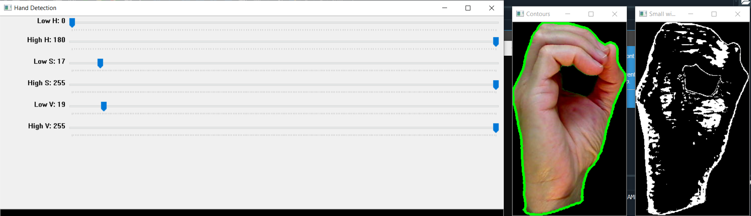

**Testing Script**

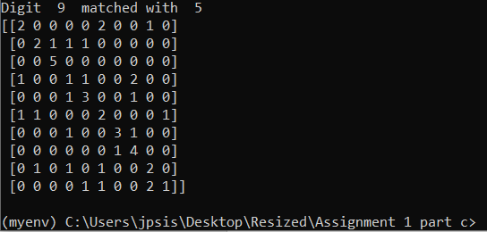

|  |  |  |  |  |  |  |  |  |  |  |  |  |  |  |  |  |  |  |  |  |  |  |  |  |  |  |  |  |  |  |  |  |  |  |  |  |  |  |  |  |  |  |  |  |  |  |  |  |  |  |  |  |  |  |  |  |  |  |  |  |  |  |  |  |  |  |  |  |  |  |  |  |  |  |  |  |  |  |  |  |  |  |  |  |  |  |  |  |  |  |  |  |  |  |  |  |  |  |  |  |  |  |  |  |  |  |  |  |  |  |  |  |  |  |  |  |  |  |  |  |  |  |  |  |  |  |  |  |  |  |  |  |  |  |  |  |  |  |  |  |  |  |  |  |  |  |  |  |
| --- | --- | --- | --- | --- | --- | --- | --- | --- | --- | --- | --- | --- | --- | --- | --- | --- | --- | --- | --- | --- | --- | --- | --- | --- | --- | --- | --- | --- | --- | --- | --- | --- | --- | --- | --- | --- | --- | --- | --- | --- | --- | --- | --- | --- | --- | --- | --- | --- | --- | --- | --- | --- | --- | --- | --- | --- | --- | --- | --- | --- | --- | --- | --- | --- | --- | --- | --- | --- | --- | --- | --- | --- | --- | --- | --- | --- | --- | --- | --- | --- | --- | --- | --- | --- | --- | --- | --- | --- | --- | --- | --- | --- | --- | --- | --- | --- | --- | --- | --- | --- | --- | --- | --- | --- | --- | --- | --- | --- | --- | --- | --- | --- | --- | --- | --- | --- | --- | --- | --- | --- | --- | --- | --- | --- | --- | --- | --- | --- | --- | --- | --- | --- | --- | --- | --- | --- | --- | --- | --- | --- | --- | --- | --- | --- | --- | --- | --- | --- |
| |  |  |  |  |  |  |  |  |  |  |  |  | | --- | --- | --- | --- | --- | --- | --- | --- | --- | --- | --- | --- | |  |  | Predicted Values | | | | | | | | | | |  |  | 0 | 1 | 2 | 3 | 4 | 5 | 6 | 7 | 8 | 9 | | Actual Values | 0 | 2 | 0 | 0 | 0 | 0 | 2 | 0 | 0 | 1 | 0 | | 1 | 0 | 2 | 1 | 1 | 1 | 0 | 0 | 0 | 0 | 0 | | 2 | 0 | 0 | 5 | 0 | 0 | 0 | 0 | 0 | 0 | 0 | | 3 | 1 | 0 | 0 | 1 | 1 | 0 | 0 | 2 | 1 | 0 | | 4 | 0 | 0 | 0 | 1 | 3 | 0 | 0 | 1 | 0 | 0 | | 5 | 1 | 1 | 0 | 0 | 0 | 2 | 0 | 0 | 0 | 1 | | 6 | 0 | 0 | 0 | 1 | 0 | 0 | 3 | 1 | 0 | 0 | | 7 | 0 | 0 | 0 | 0 | 0 | 0 | 1 | 4 | 0 | 0 | | 8 | 0 | 1 | 0 | 1 | 0 | 1 | 0 | 0 | 2 | 0 | | 9 | 0 | 0 | 0 | 0 | 1 | 1 | 0 | 0 | 2 | 1 | | |  | | --- | | Outcome: | | Gesture 0 is match 40% of the time | | Gesture 1 is match 40% of the time | | Excellent match | | Gesture 3 is match 20% of the time | | Gesture 4 is match 60% of the time | | Gesture 5 is match 40% of the time | | Gesture 6 is match 60% of the time | | Gesture 7 is match 80% of the time | | Gesture 8 is match 40% of the time | | Gesture 9 is match 20% of the time | |  | |

This resulted in a 25/50 score.